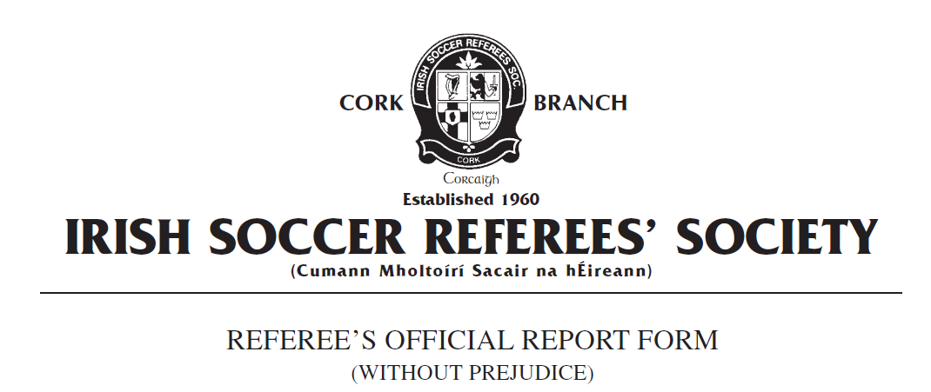

Competition:
Match:
Place & Date of Match:
I have to report the following: Assault of Match Official /Misconduct Against a Match Official
In the XX^{h} minute of the above-mentioned match I had reason to send from the field of play Team A number X, named as Joe Bloggs on the teamsheet, for violent conduct and assault of a match official.
In the XXth minute I awarded a penalty kick to Team B. I was immediately surrounded by several Team A players protesting the decision and showing dissent towards me. As I was in the process of dealing with this incident of mobbing, I was approached by the Team A number X and he assaulted me by deliberately and directly pushing me with both hands in the chest area. There was no doubt I was the intended target of this action and I had a clear and unobstructed view of the player assaulting me.
Several Team A players pulled the Team A number X away from me when they witnessed this. Once order was restored, I issued Team A number X with a red card in accordance with FIFA Law 12: Fouls and Misconduct: Disciplinary Action – ‘Violent Conduct’. Team A number X left the field of play without further incident.
I then abandoned the game due to the assault as I was in fear of my personal safety considering the incident which had just taken place. The score was 2-2 at the time of abandonment in the 65th minute and both home and away team had 11 players participating in the match prior to the sending off of Team A number X. I was escorted from the Field of play by members of Team B and left the ground at XX. I reported the incident to the on-duty Garda at XXX Garda Station at XXpm.
This concludes my report.
Yours faithfully,
_____________________
Referee Cork ISRS

