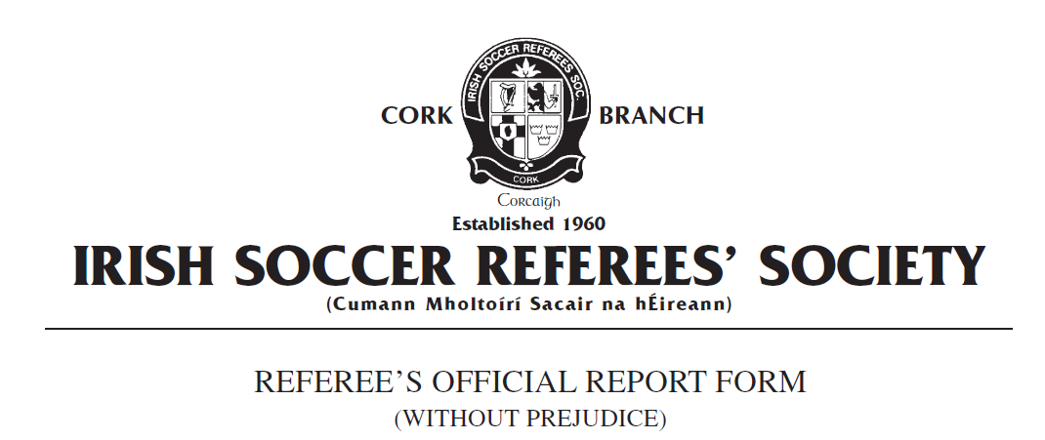

Competition:
Match:
Place & Date of Match:
I have to report the following: Sending from the field of play

In the XXth minute of the above mentioned match, I had reason to dismiss from the field of play Team A number X, named as Joe Bloggs on the team sheet, for denying the opposing team a goal by a handball offence.

In the XXth minute of the above match, a Team B player took a shot that was clearly goal bound from just inside the penalty area. With the Team A goalkeeper recovering his position on the opposite side of the goal from a save immediately prior, Team A number X dived across the goal with his arm outstretched which made his body unnaturally bigger. The ball struck the arm of the Team A player inside the Team A goal area approximately one metre from the goal line. There were no other Team A players in a position to prevent the ball from entering the goal at the time of contact with the arm and the action by Team A number X denied the opposition a clear goal.

Team A number X was issued a red card and dismissed from the field of play in accordance with FIFA Law 12 Fouls and Misconduct : 'Sending Off Offences - denying the opposing team a goal or an obvious goalscoring opportunity by a handball offence.'

Team A number X left the field of play without further incident. Play was restarted with a penalty kick awarded to Team B.

Yours faithfully,
_____________________
Referee Cork ISRS

