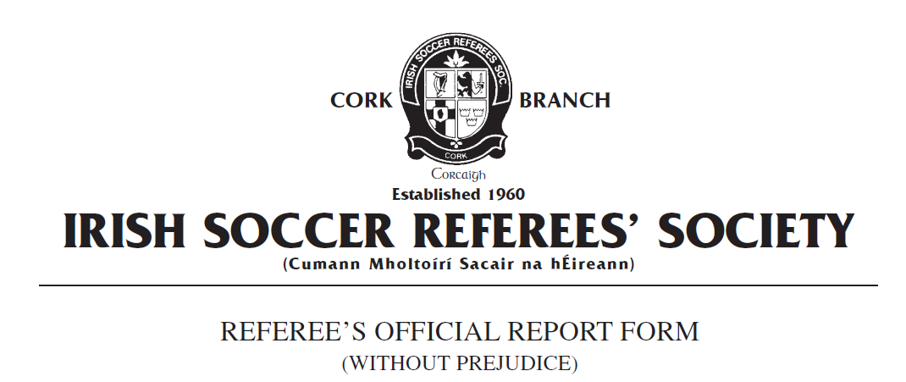

Competition:
Match:
Place & Date of Match:
I have to report the following: Sending Off from the field of play
In the XX minute of the above mentioned game I had reason to send from the field of play Team A number X, named as Joe Bloggs on the teamsheet, for denying an obvious goalscoring opportunity to an opponent.

In the 90+1 minute of the game, having received the ball from a teammate, an opposition player was advancing towards the Team A goal and was being chased by Mr Bloggs. As the Team B player was approximately three metres outside the The Team A penalty area, Mr Bloggs pulled his opponent's jersey which prevented him from progressing with the ball. Team B’s number X’s overall movement was towards the Team A goal and Team B number X was clearly in control of the ball at the time of the incident. There were no other players from Team A that were in a covering position and Mr Bloggs actions denied Team B a clear goal scoring opportunity. I was 10 metres from this incident when it took place and clearly saw the offence committed.

Mr Bloggs was subsequently issued with a red card in accordance with FIFA Law 12 Fouls and Misconduct : Sending Off Offences: ‘Denying a goal or an obvious goalscoring opportunity to an opponent whose overall movement is towards the offenders goal by an offence punishable by a free kick”.

Mr Bloggs left the field of play without further incident. Play was restarted with a direct free kick to Team B.

This concludes my report.

Yours faithfully,
_____________________
Referee Cork ISRS

