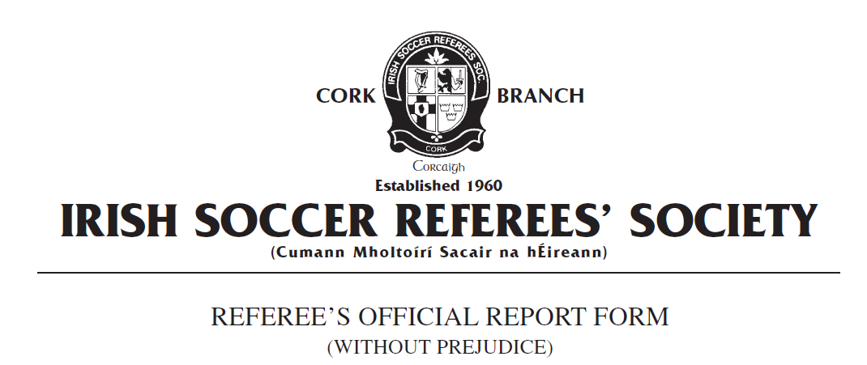

Competition:
Match:
Place & Date of Match:
I have to report the following: Dismissal from the Technical Area
In the XXth minute of the above-mentioned match, I had reason to expel from the field of play the Team A Manager, named as XXXXX on the team sheet, for failing to act in a responsible manner.
Having just conceded a goal to Team B, the Team A manager left the technical area and came approximately 10-15m onto the field of play and began to aggressively contest the decision and verbally abuse me shouting “That’s a fucking disgrace” and “You’re fucking brutal”. I was approximately 20 metres away at the time and clearly heard the words used by the Team A manager.
The Team A manager continued his abuse stating “I don’t even care if you send me off, that was fucking brutal, he was offside. You’re a disgrace.”
I issued the Team A Manager a red card in accordance with FIFA Law 12 Fouls and Misconduct Sending Off Offences – “Deliberately leaving the technical area to show dissent towards or remonstrate with a match official / act in a provocative or inflammatory manner” and “Using offensive, insulting or abusive language and/or gestures.”
The Team A manager was dismissed from the field of play and its immediate surrounds in accordance with FIFA Law 5 The Referee – Powers and Duties – “Takes action against team officials who fail to act in a responsible manner and warns or shows a yellow card for a caution or a red card for a sending off from the field of play and its immediate surrounds, including the technical area.”
From the time of the incident and red card being shown, it took approximately 2mins for the Team A Manager to leave the field of play and its immediate surrounds. Play was restarted with a kick off to Team A.
At the conclusion of the match, the Team A manager re-entered the field of play and approached me in the centre circle and again stated “Fucking terrible” with a dismissive hand gesture.
Yours faithfully,
_____________________
Referee Cork ISRS

