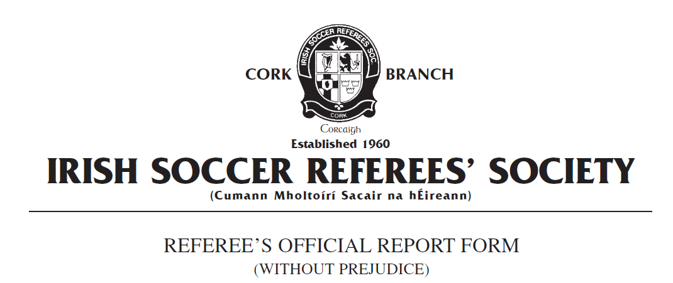

Competition:
Match:
Place & Date of Match:
I have to report the following: Sending Off from the field of play
In the XXth minute of the above-mentioned match I had reason to send from the field of play Team A number X, named as Joe Bloggs on the teamsheet, for serious foul play.
In the XXth minute of play, Mr Bloggs was in possession of the ball approximately 5 metres outside his own penalty area in the centre of the field of play. As he was attempting to carry the ball out of his defensive third, Mr Bloggs lost control of possession. In an attempt to regain possession, Mr Bloggs lunged into a challenge from the front with both feet against an opponent. Mr Bloggs lunged with moderate force in a manner that clearly endangered the safety of his opponent. Mr Bloggs studs made contact with his opponents shins above ankle height. I was approximately 10 metres away from the challenge when it occurred and had a clear and unobstructed view of the challenge.
I immediately issued Mr Bloggs with a red card in accordance with FIFA Law 12 Fouls and Misconduct: Disciplinary Action: Sending Off Offences: Serious Foul Play – “A tackle or challenge that endangers the safety of an opponent or uses excessive force or brutality must be sanctioned as serious foul play. Any player who lunges at an opponent in challenging for the ball from the front, side or behind using one or both legs, with excessive force or endangers the safety of an opponent is guilty of serious foul play.”
Mr Bloggs left the field of play without further incident. The Team B player required medical treatment for approximately two minutes before continuing with his participation in the game.
Play was restarted with a direct free kick to Team B.
This concludes my report.
Yours faithfully,
Referee Name
Referee Cork ISRS

