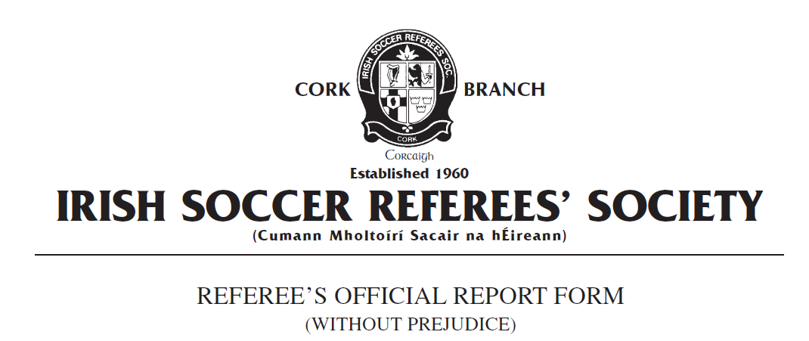

Competition:
Match:
Place & Date of Match:
I have to report the following: Sending Off from the field of play
In the XX minute of the above mentioned game I had reason to send from the field of play Team A number X, named as Joe Bloggs on the teamsheet, for receiving a second caution in the same match.

In the XX1 minute of play, Mr Bloggs received a caution for unsporting behaviour having committed a late reckless challenge when he deliberately body checked his opponent approximately 20 metres outside the Team A penalty area in the centre of the field of play. Mr Bloggs opponent had played the ball to a team mate in a wider position and was subsequently body checked by Mr Bloggs after he had released the ball. I was approximately 10 metres from the incident when it took place and I had a clear and unobstructed view of the offence. Mr Bloggs was cautioned in accordance withFIFA Law 12 Fouls and Misconduct : Disciplinary Action : Cautions for Unsporting Behaviour - 'Commits in a reckless manner a direct free kick offence.'

In the XX2 minute of the game, I had reason to issue a second caution to Mr Bloggs for stopping a promising attack. After receiving the ball from a teammate, an opposition player was advancing towards the Team A goal and was being chased by Mr Bloggs. As the Team B player was approximately three metres outside the The Team A penalty area, Mr Bloggs pulled his opponent's jersey which prevented him from reaching the ball which was subsequently cleared from the penalty area by another Team A player who was in a
covering position. I was 10 metres from this incident when it took place and clearly saw the offence committed. Mr Bloggs was issued with a second caution in accordance with FIFA Law 12 Fouls and Misconduct: Disciplinary :Cautions for Unsporting Behaviour - 'Commits any other offence which interferes with or stops a promising attack.'

Mr Bloggs was subsequently issued with a red card in accordance with FIFA Law 12 Fouls and Misconduct : Sending Off Offences: 'receiving a second caution in the same match.'
Mr Bloggs left the field of play without further incident. Play was restarted with a direct free kick to Team B.

This concludes my report.

Yours faithfully,
_____________________
Referee Cork ISRS

