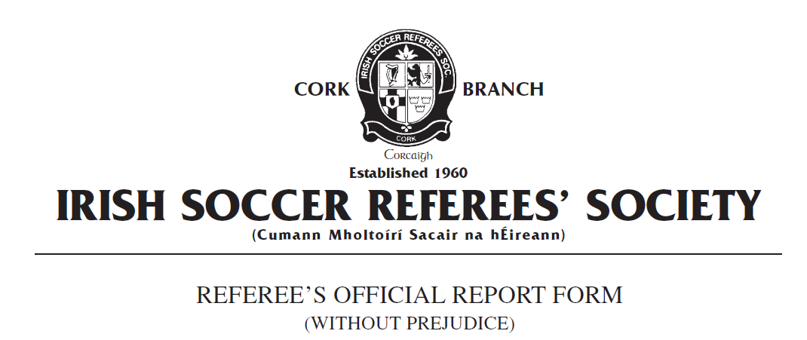

Competition:
Match:
Place & Date of Match:
I have to report the following: Sending from the field of play
In the XX minute of the above-mentioned match, I had reason to expel from the field of play Team A number X, named as Joe Bloggs on the team sheet, for violent conduct.
In the XX minute, Team A number X attempted to take the ball past Team B number X in the Team B penalty area near the goa line. Team B number X dispossessed Team A number X and cleared the ball from the penalty area towards the halfway line. As I followed play my attention was drawn back to the penalty area where I observed Team A number X swing his arm back in the direction of Team B number X which resulted in Team B number X being struck in the face with moderate force with the forearm/elbow area of Team A number X. Team A number X’s arm was rigid and his fist clenched and there was a clear swinging motion in the direction of the Team B player. I was approximately 20 metres from the incident when it took place however I had a clear and unobstructed view of the incident.
I stopped play and issued Team A number X with a red card in accordance with FIFA LAW 12 Fouls and Misconduct – Violent Conduct: “Violent Conduct is when a player uses or attempts to use excessive force or brutality against an opponent when not challenging for the ball”.
Team B number X required no medical treatment and participated in the remainder of the match.
Team A number X left the field of play without further incident.
Play was restarted with a direct Free Kick to Team B.
This concludes my report.
Yours faithfully,
_____________________
Referee Cork ISRS

